EXP NO 1:
CREATE A SIMPLE CLOUD SOFTWARE APPLICATION AND PROVIDE IT AS A SERVICE USING ANY CLOUD SERVICE PROVIDER TODEMONSTRATE SOFTWARE AS A SERVICE (SAAS).

AIM: To create a simple cloud software application and provide it as a service using any cloud service provider to demonstrate software as a service (saas).
procedure: step1: go to zoho.com step 2: login to the zoho.com step 3: select one application step 4: enter application name step 5: created new application step 6: select one form step 7: the software has been created.
Output
1.DOCTOR’S APPOINTMENT
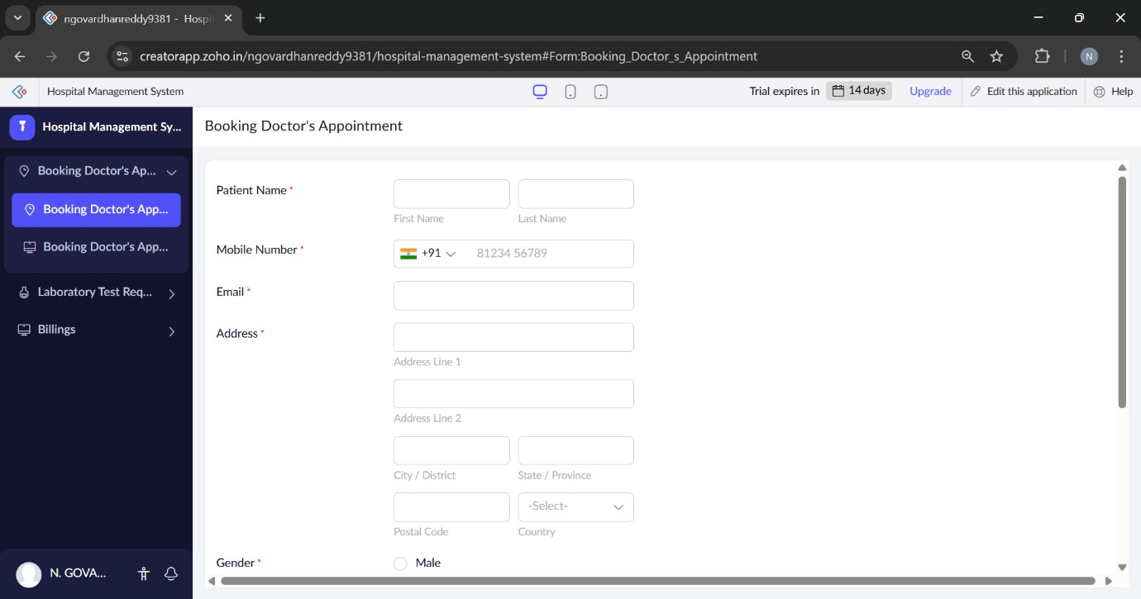
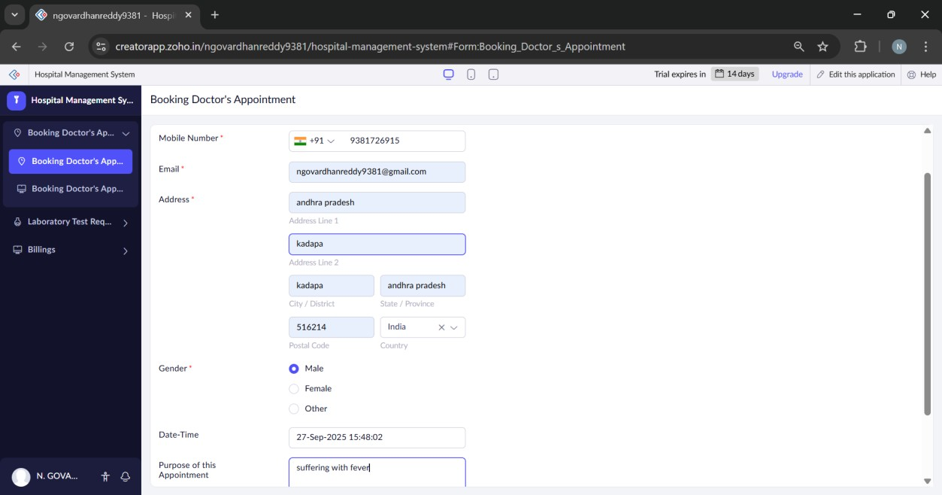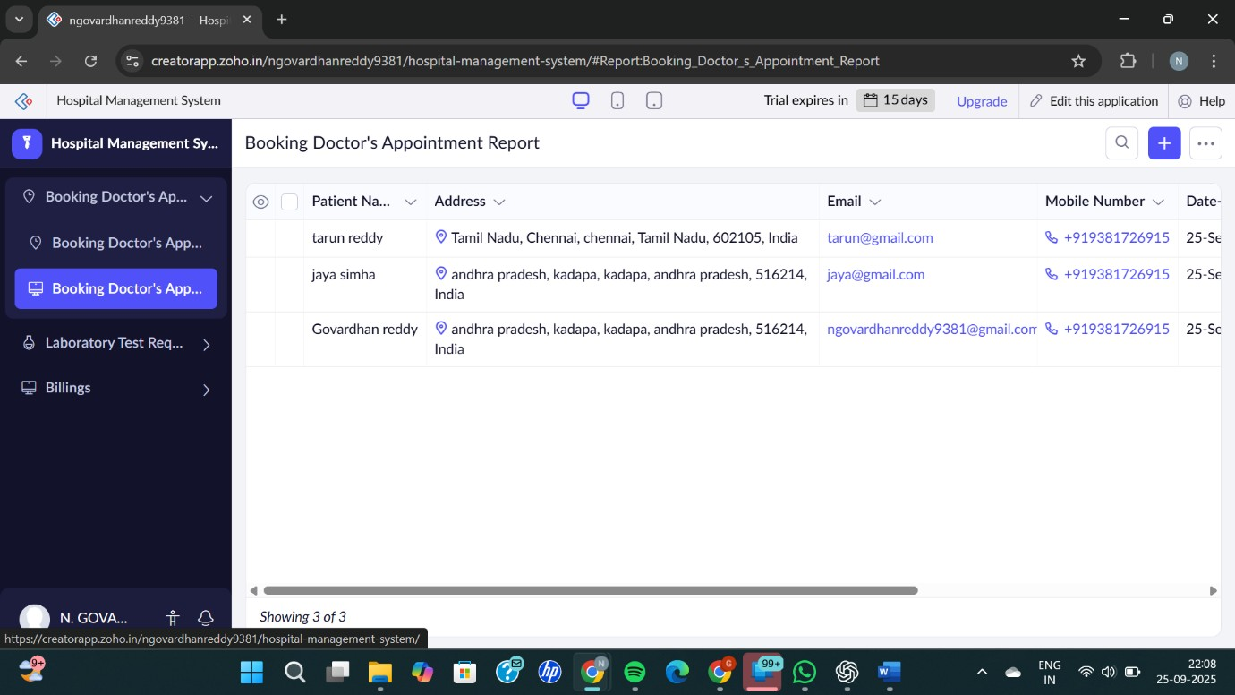

2.laboretory request
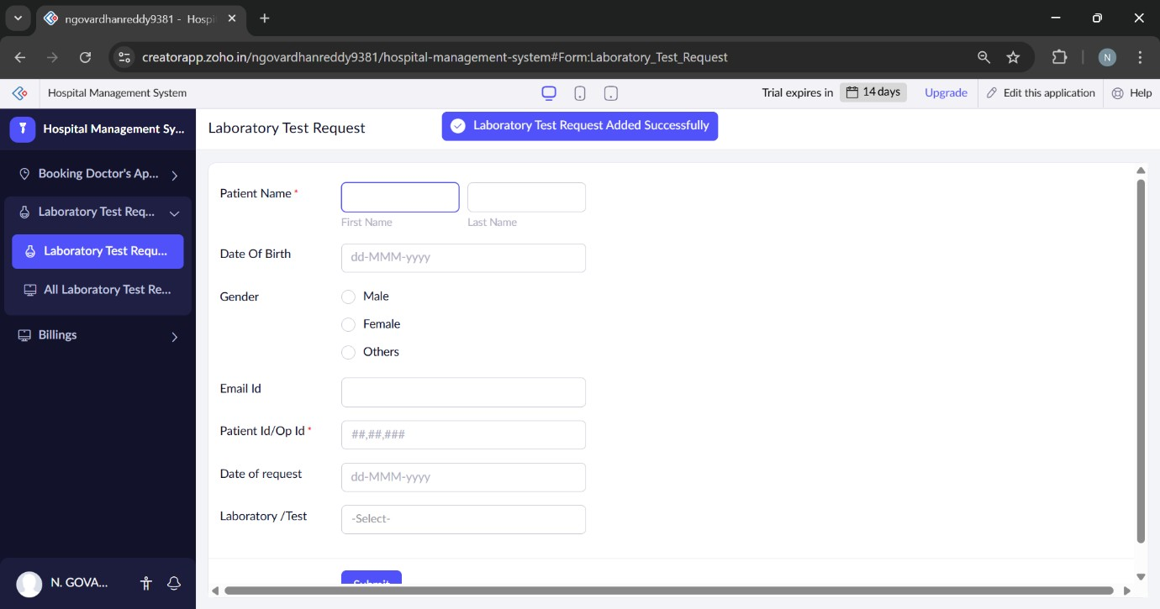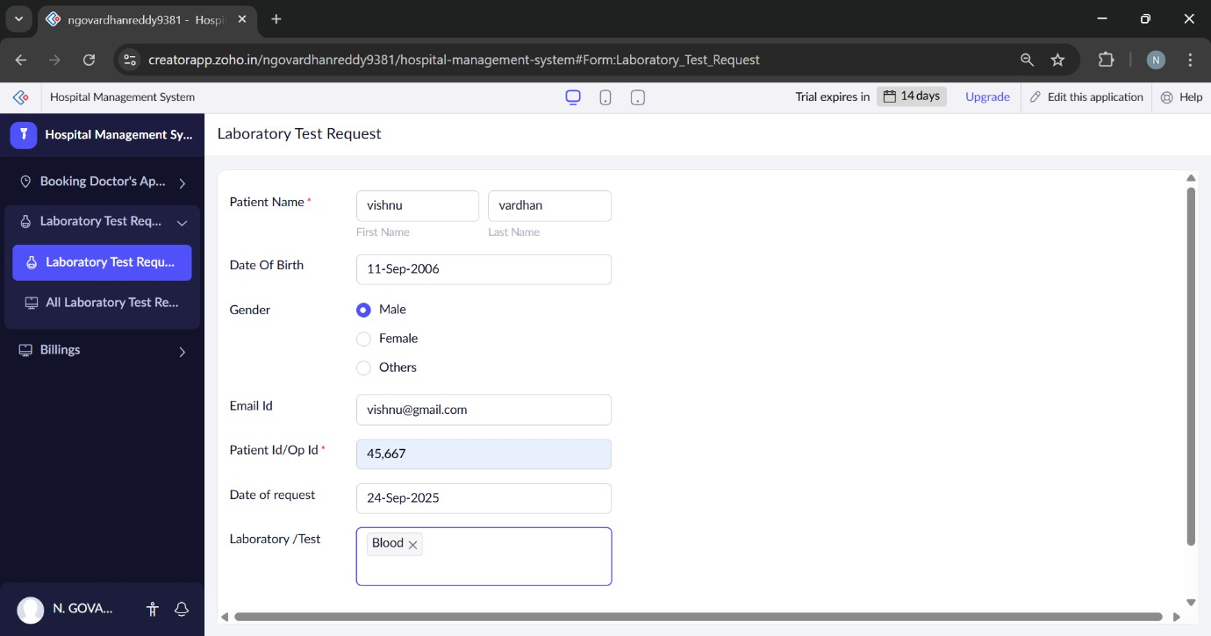
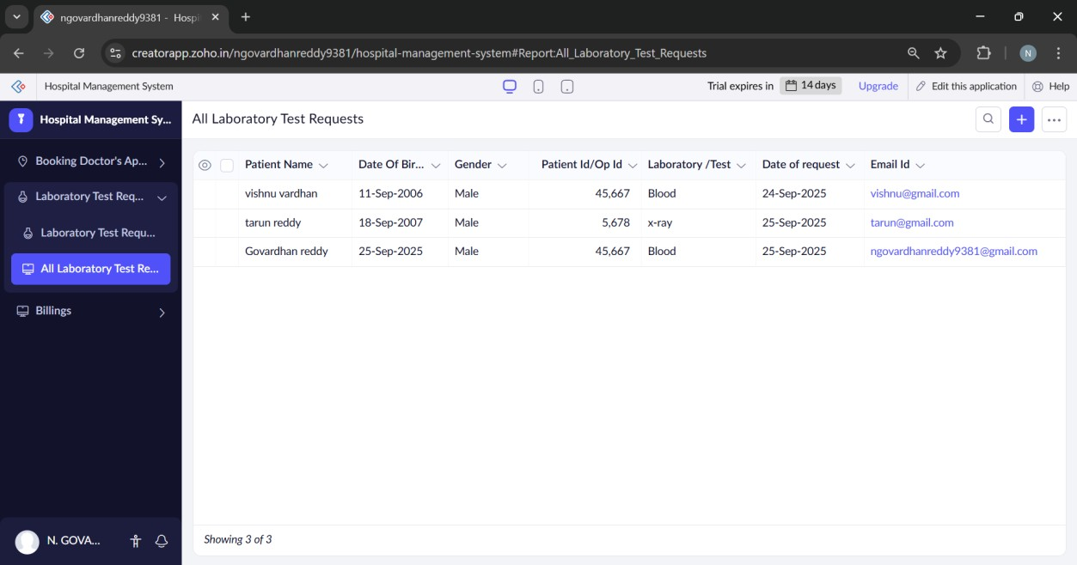
3.All billings
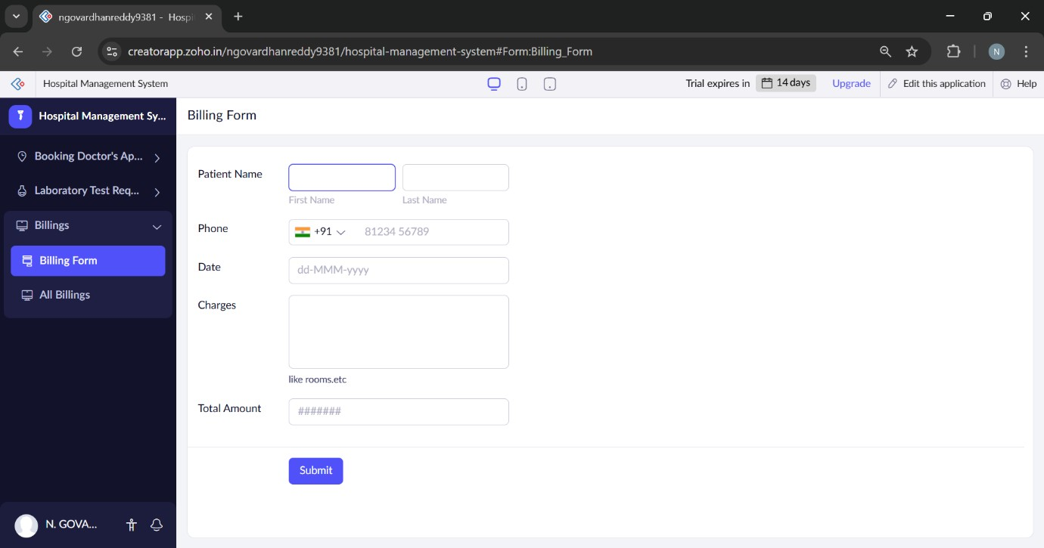
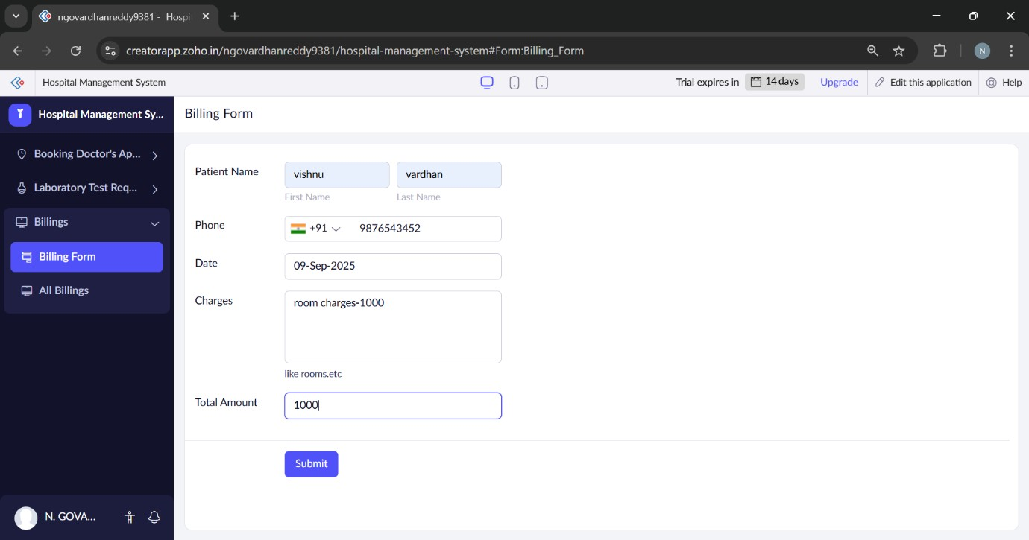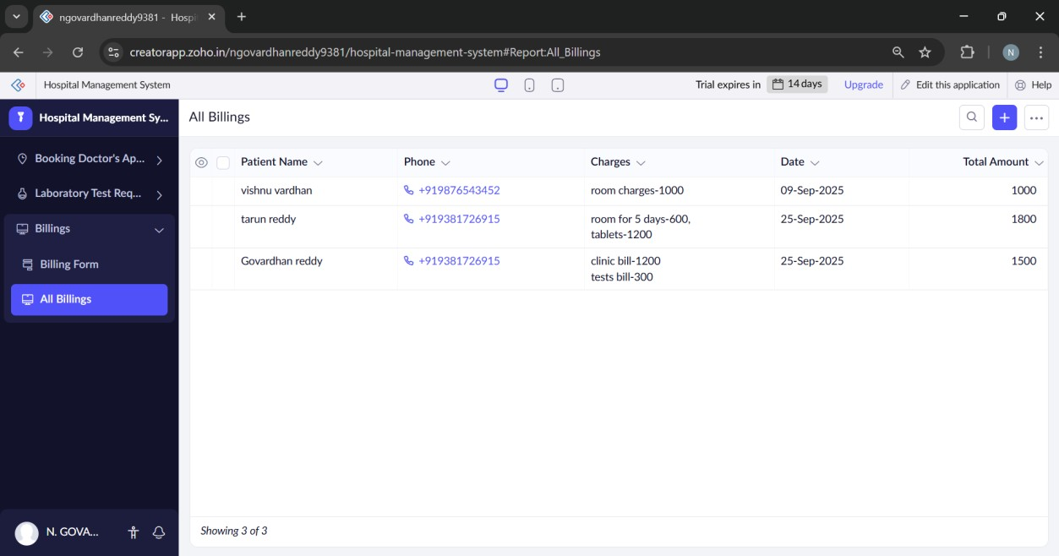
RESULT:
Successfully created a simple cloud software application and provide it as a service using any cloud service provider to demonstrate software as a service (SaaS).

